The Second Announcement

International Symposium on Dam Safety and Detection of Hidden Troubles of Dams and Dikes
November 1-3, 2005
Xi’an, China

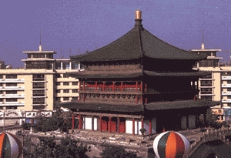

Sponsored by:
Department of Construction and Management, Ministry of Water Resources (MWR), P. R. China

Organized by:
China Institute of Water Resources and Hydropower Research
Nanjing Hydraulic Research Institute
Provincial Authorities of Water Resources, Shaanxi Province

Co-Organized by:
Chinese National Committee on Large Dams

Introduction
There are more than 45,000 large dams built worldwide, most of which play an important role in the global economic and social development. While dams are generating great benefits, their safety problems cannot be neglected. Therefore dam safety and its operational management are being paid more and more attention to. This International Symposium on Dam Safety and Detection of Hidden Troubles of Dams and Dikes (INSDSD) aims at providing a forum for exchange of views and experiences among researchers, engineers, practitioners and administrators interested in the field.

Objectives
- To improve the safety operation and management of dams and dikes;
- To extend the application of new technologies, research results and new materials for construction, monitoring and management of dams and dikes;
- To introduce advanced equipment and technology in the field of safety monitoring and management;
- To strengthen international technological cooperation and exchange.

Organization

Organizing Committee
Chairman: Mr. Liu Ning, Chief Engineer, MWR, P. R. China

Scientific Committee
Chairmen: Mr. C. B. Viotti, President, International Commission on Large Dams (ICOLD)
Mr. Jia Jinsheng, Vice President, China Institute of Water Resources and
Hydropower Research; Vice President, ICOLD
Mr. Cai Yuebo, Vice President, Nanjing Hydraulic Research Institute;
Executive Vice Director, Dam Safety Management Center, MWR

Date and Venue

Date: Nov. 1- 3, 2005

Venue: Orient Hotel, Xi’an City, Shaanxi Province
Orient Hotel is located at No. 393, Zhuque Avenue, south suburb cultural zone, Xi’an City. There are 293 guest rooms of different styles and 3 conference halls equipped with modern communication facilities of high technology in the Hotel.
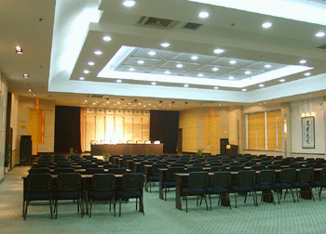


Room Rate: Double-bed room US$ 35 per day per room
Single-bed room US$ 30 per day per room
Please send your reservation indicating your room type and staying days to the Secretariat of LOC before Oct. 10, 2005.
Hotel Tel.: +86-29-8765-4321
Fax: +86-29-8526-1590 / 1768
http:// www.orienthotel-xian.com

Topics
The topics to be discussed at the Symposium include
1. Dam safety and its operational management:
- Methods and standards of operational management, safety evaluation and safety inspection of reservoir dams;
- R & D or application of new technology, methodology and advanced equipment in the field of dam safety monitoring and defects detection;
- Development and application of dam safety information systems;
- New materials for dike and dam protection engineering;
- Analysis of dam breach factors, procedures and countermeasures.

2. Detection of hidden troubles of dikes and dams:
- R & D and application of new technology and equipment;
- Data analysis technology, status quo and development prospective for dam and dike safety monitoring and detection;
- R & D and application of dike safety information systems.

And any other appropriate themes if necessary.

Call for Papers

Abstracts, not exceeding 300 words, are invited relating to the above topics. The abstracts in Word Format should contain the following information: name, title, telephone, fax, postal and email addresses of author(s) for correspondence and communication, and a maximum of 5 keywords.

Deadlines:
July 10, 2005 – submission of abstracts
July 20, 2005 – notification of acceptance and paper format
September 30, 2005 – submission of full papers

Proceedings

All papers (both English and Chinese versions) will be printed out in a collection volume before the Symposium, and papers of high quality will be selected and published in Proceedings after the Symposium.

Agenda

Oct. 31, 2005 Registration and check-in at Orient Hotel
Nov. 1, 2005 Morning Opening ceremony and keynote presentations
Afternoon Plenary academic presentations
Nov. 2, 2005 Academic presentations in two different conference halls
Nov. 3, 2005 Morning Visit Shibianyu Reservoir, Chang’an County, Shaanxi Province
Afternoon Visit terra-cotta soldiers and horses
Nov. 4-8, 2005 Post-Symposium technical tours

Language
The Symposium language is English. Simultaneous translation is available for Symposium keynote presentations.
Registration Fees
 | Payment
 | Before Sep. 30 , 2005 | On or After Sep. 30, 2005
Participant | US$ 320 | US$ 400
Accompanying Person | US$ 160 | US$ 200

Please remit the due payment (covering registration fee, hotel room fee, fee for Post-Symposium Technical Tours) with a note stating “Fees for INSDSD” according to the following information:
Account No.: 006647145310003242
Account Holder: Nanjing Hydraulic Research Institute
Bank: Nanjing Branch, Bank of Communications, China
Swift Code: COMMCNSHNJG
Post-Symposium Technical Tours
2 routes for Post-Symposium Technical Tour are available. If there are less than 6 persons for each route, this route will be automatically cancelled.
Route A1 (Nov. 4 – 7, 2005): Xi’an – Chongqing – The Three-Gorge Project
Nov. 4, 2005 | Flying to Chongqing City, having a city tour and embarking on ship at 20:00pm;
Nov. 5, 2005 | Cruising downstream through the Three Gorges and sight-seeing (Ghost town in Fengdu, Zhangfei Temple, Qutang Gorge, etc.), overnight on ship;
Nov. 6, 2005 | Cruising downstream (passing Longmen Gorge, Bawu Gorge, Dicui Gorge, Fair Lady Peak, etc.), arriving at the Three-Gorge Project at 20:00pm and staying in the Three-Gorge Hotel;
Nov. 7, 2005 | Morning, visiting the Three-Gorge Project;
Nov. 7, 2005 | Afternoon, visiting the Gezhouba Project;
Nov. 7, 2005 | Evening, end of the tour after dinner.
Total fee is US$ 600 per person, covering food, accommodations, transport and tickets for partial scenic spots.
Route A2 (Nov. 4 – 5, 2005): Xi’an – The Xiaolangdi Project – Zhengzhou
Nov. 4, 2005 | Going to Luoyang City by bus for 4 hrs, visiting the Longmen Grottoes and the Xiaolangdi Project, and stay in Xiaolangdi;
Nov. 5, 2005 | Morning, going to Zhengzhou City by bus, and visiting the Yellow River Museum;
Nov. 5, 2005 | Afternoon, end of the tour after lunch.
Total fee is US$ 300 per person, covering food, accommodations, transport and tickets for relevant scenic spots.
Introduction of Visiting Sites
1. The Shibianyu Reservoir
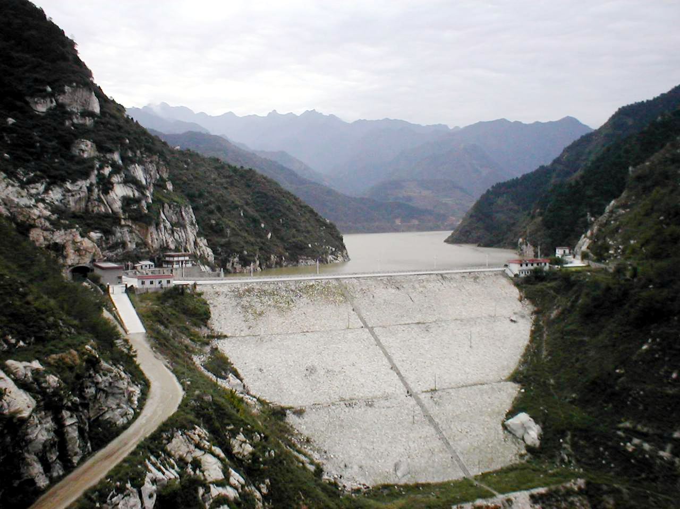
The Shibianyu Reservoir, located at Chang’an District, Xi’an City, is a medium-scale reservoir with purposes of irrigation, flood control, hydropower generation and urban water supply. It is composed of dam, water conveyance tunnel, spillway tunnel, power stations at dam toe with a total reservoir storage of 28.1 million m³. The dam is a rockfill one with an asphalt inclined anti-seepage core covered by geo-synthetic membrane deck. The dam is of 85m high and 265m long with a crest width of 7.5m. The Reservoir is a standby reservoir for urban water supply.
The construction of the Reservoir was started in 1971 and fundamentally completed in 1980. Since the trial storage in 1981, there occurred leakage three times with a max. leakage of 1.73m³/s. In 1999, the dam was reinforced by injection of cement, sand and clay at the lower part of the inclined core of the dam.
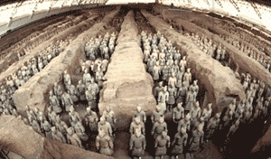
2. Terra-cotta Soldiers and Horses
In March 1974, a farmer accidentally found many broken pieces of terracotta figurines, 1.5 km away from the tomb of Qin Shi Huang. Approved by archaeologists, that was the First Pit of terra-cotta soldiers and horses in a rectangle shape. In 1976, the Second Pit and the Third Pit were discovered respectively 20m and 25m away from the north side of the First Pit. The total area is 22,780 m².
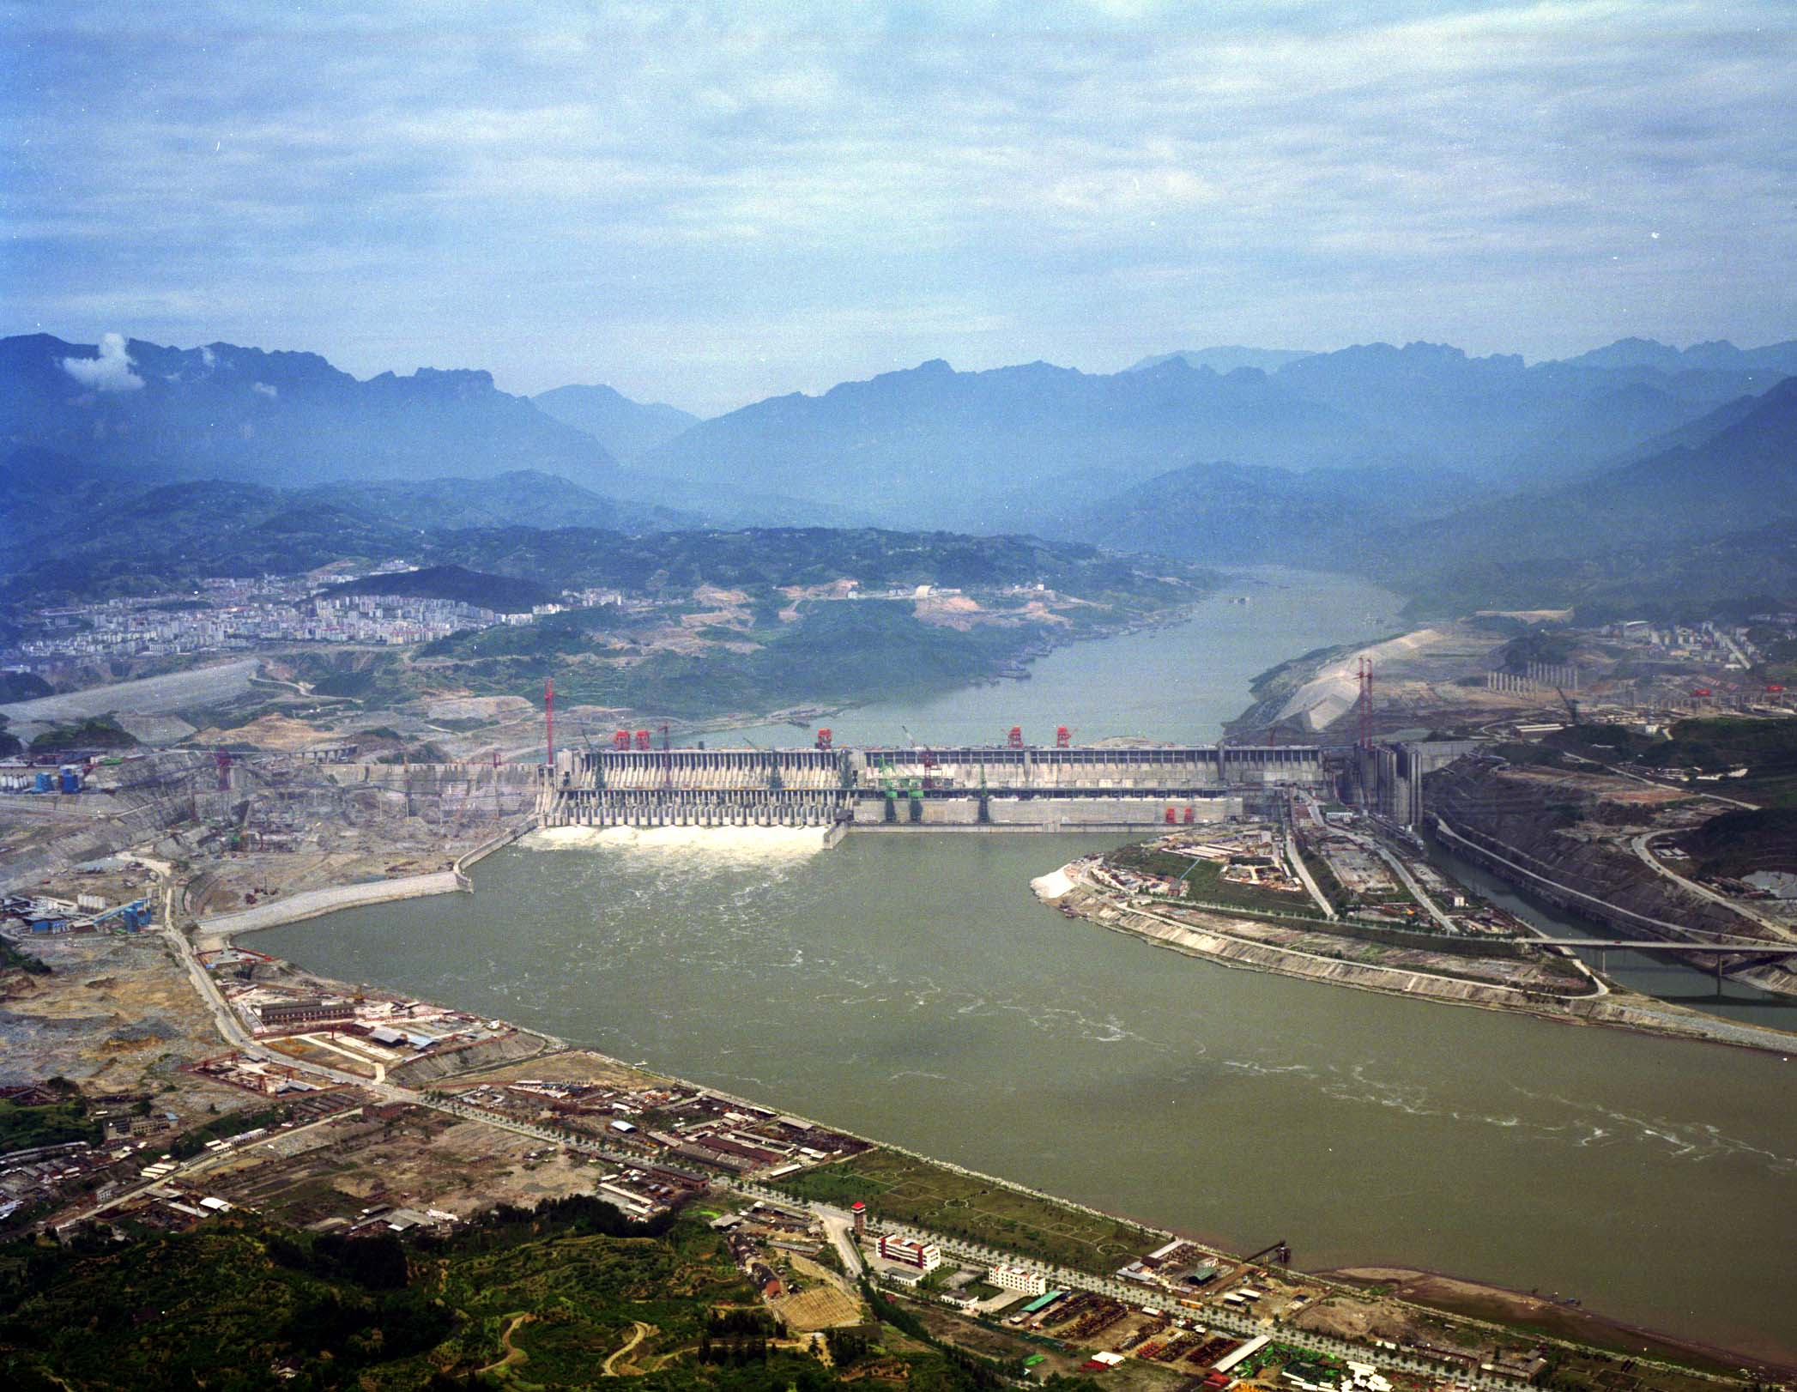
3. The Three-Gorge Project
The Three-Gorge Project is a key project to regulate and develop the Yangtze River with multi-benefits of flood control, hydropower generation and navigation. The dam site is located at Sandouping, Yichang City, Hubei Province. There are totally 32 hydropower generating sets with each installed capacity of 0.7 million kW. The normal storage level is 175m with a total storage capacity of 39.3 billion m³, among which the capacity for flood control is 22.15 billion m³. After the construction completion, the flood control standard will be improved from current once ten years to once a hundred years in Jingjiang Reach. The reliability and flexibility of flood control dispatching in the middle and lower reaches of the Yangtze River will be greatly improved as well. The project will mainly supply hydropower to the east and middle parts of China. Meanwhile, the navigation channel of 660 km long from Yichang to Chongqing will be obviously upgraded with an improved single-direction navigation capacity of 50 million tons.
4. The Longmen Grottoes
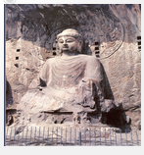
The Longmen Grottoes are located at both banks of the Yihe River, south suburb, 13 km away from Luoyang City, Henan Province. In 1961, it was declared by the State Council that the Grottoes should be protected among the first group of the national key protected heritages. In 1982, it was declared by the State Council that the Grottoes were listed as one of the first group of national famous scenic spots. In November 2000, the Longmen Grottoes were listed in the catalogue of the World Culture Heritage by UNESCO.
5. The Xiaolangdi Project
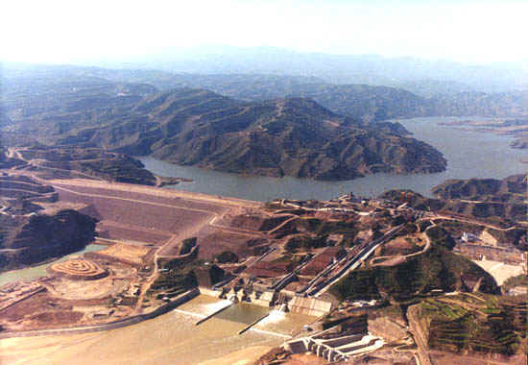
The Xiaolangdi Project is located at the last valley of the middle reach of the Yellow River, 40 km away from the north of Luoyang City with a control catchment area of 0.964 million km². The project is composed of such three parts as dam, flood and sand discharge systems and hydropower generating sets. The dam is an inclined core rockfill dam with a height of 154m. It has multifunctions of flood and ice control, siltation deduction, irrigation, water supply and hydropower generation. After the completion of the project, with the supporting operation of the Sanmenxia Reservoir, the flood control standard of the lower reach of the Yellow River can be improved from once 60 years to once 1000 years. The threat of ice blocking is thus fundamentally dismissed. Siltation in the downstream river channel will be kept stable for 20 years. This project also improves the conditions for irrigation and urban water supply. With the mean annual hydropower production of 5.1 billion kW, the power station is an ideal one for hump modulation.
Exhibition
A technical exhibition will be organized for new technology, facilities and materials at Orient Hotel parallel with the Symposium.
Secretariat
1. For further information about post-symposium technical tours and exhibition, please contact:
Mr. Wang Lianxiang
China Institute of Water Resources and Hydropower Research
Add.: No. 20, Chegongzhuang West Rd., Beijing, China, 100044
Tel.: +86-10-6843-5228 / 6878-5106
Fax: +86-10-6871-2208
e-mail: chincold@iwhr.com
2. For further information about registration, submission of abstracts, please contact:
Ms. Sun Feng
Nanjing Hydraulic Research Institute
Add.: No. 223, Guangzhou Rd., Nanjing, China, 210029
Tel.: +86-25-8582-8116
Fax: +86-25-8373-4321
e-mail: fsun@nhri.cn

3. For submission of papers, please send the digital copy by email to the following:

Mr. Wang Xinghui
e-mail: xhwang@nhri.cn
Registration Form
International Symposium on Dam Safety and Detection of Hidden Troubles of Dams and Dikes (ISDSD)

Given Name: Family Name: Sex:
Title: Date of Birth: Passport No.
Institute / Company:
Postal Address:
Tel.: Fax:
E-mail:
1. Registration Fee
 | Before Sep. 30, 2005 | On or After Sep. 30, 2005 | Person (s)
Participant | US$ 320 | US$ 400
Accompanying person | US$ 160 | US$ 200

Subtotal:
2. Post-Symposium Technical Tour
Date | No. | Route | US$ / Person | Person (s)
Nov. 4–7, 2005 | A1 | Xi’an–Chongqing–The Three-Gorge Project | 600
Nov. 4–5, 2005 | A2 | Xi’an–The Xiaolangdi Project-Zhengzhou | 300

Subtotal:
3. Hotel Room Reservation
Hotel Name | Class | Room Type | Room Rate | No. of Room | Days
Orient Hotel | **** | Double-bed room | US$ 35
Orient Hotel | **** | Single-bed room | US$ 30
Please write down the name of the person who shares the same room with you.
Subtotal:

Total:
Signature: Date:

Please remit total payment to the following account: |  | Please contact for more information:
Account No.: 006647145310003242 |  | Ms. Sun Feng
Account Holder: Nanjing Hydraulic Research Institute |  | 223 Guangzhou Rd., Nanjing, China, 210029
Bank: Nanjing Branch, Bank of Communications, China |  | Tel.:+86-25-8582-8116 Fax: +86-25-8373-4321
Swift Code: COMMCNSHNJG |  | E-mail: fsun@nhri.cn

