Second Announcement and Call for Papers

International Conference
Hydropower’2004

May 24-26, 2004
Yichang, China

Sponsored By:


China Yangtze Three Gorges Project
Development Corporation (CTGPC)


Qingjiang Hydroelectric Development
Co. Ltd (QDC)


Chinese Society for Hydroelectric
Engineering (CSHEE)


Chinese Hydraulic Engineering
Society (CHES)

Cosponsored By:
National Natural Science Foundation of China (NNSFC)
Chinese National Committee on Large Dams(CHINCOLD)
China Institute of Water Resources and Hydropower Research (IWHR)

Second Announcement and Call for Papers

International Conference
Hydropower’2004

INVITATION
The Organizing Committee takes a great pleasure and honor to invite engineers, scholars, specialists, consultants, managers, manufacturers, financiers, officers and all persons who are interested in hydropower development to attend the International Conference Hydropower ’2004, which will be held on May 24—26, 2004 in Yichang City, Hubei Province, China, as post- activities of ICOLD 72nd Annual Meeting that will be held in Seoul from May 16 to 22, 2004. After a successful and fruitful meeting of Hydropower ’96 (1996) and Hydropower’98 (1998), this conference will concentrate on hydropower facilities and structures, especially design, construction, monitoring and operation of high CFRD and concrete dams and the stability of large hydroturbine sets of power station and relevant operation experiences.
The objective of the International Conference Hydropower ’2004 is to provide a forum for discussion on key issues and exchange of information among researchers, scholars, engineers and decision-makers in all aspects of hydropower engineering. At the conference the attendants are encouraged to present their latest research results and exchange their experiences in hydropower development.
The International Conference Hydropower’2004 is sponsored by China Yangtze Three Gorges Project Development Corporation, Qingjiang Hydroelectric Development Co. Ltd., Chinese Society for Hydroelectric Engineering and Chinese Hydraulic Engineering Society, and co-sponsored by National Natural Science Foundation of China, Chinese National Committee on Large Dams and China Institute of Water Resources and Hydropower Research.

location
The Conference will take place on the construction site of Three Gorges Project, which is located near Yichang city, Hubei Province. The city has been proved by archeologist that there existed human traces at least 100,000 years ago, and has long been the capitals of different states or prefectures for over 2,000 years. Yichang is a tourist city with a variety of attractions rich in historical sites and cultural relics. Recently as rapid economic development Yichang has also become a modern city with convenient transportation and communication facilities. The flight between Beijing and Yicahang is available every day.

Three Gorges Project and shuibuya project

The Three Gorges Project (TGP) is located 40 km above the Yichang City. It is a vitally important and backbone project in the development and harnessing of the Yangtze River (Changjiang River). TGP serves as a multi-purpose hydro-development project producing
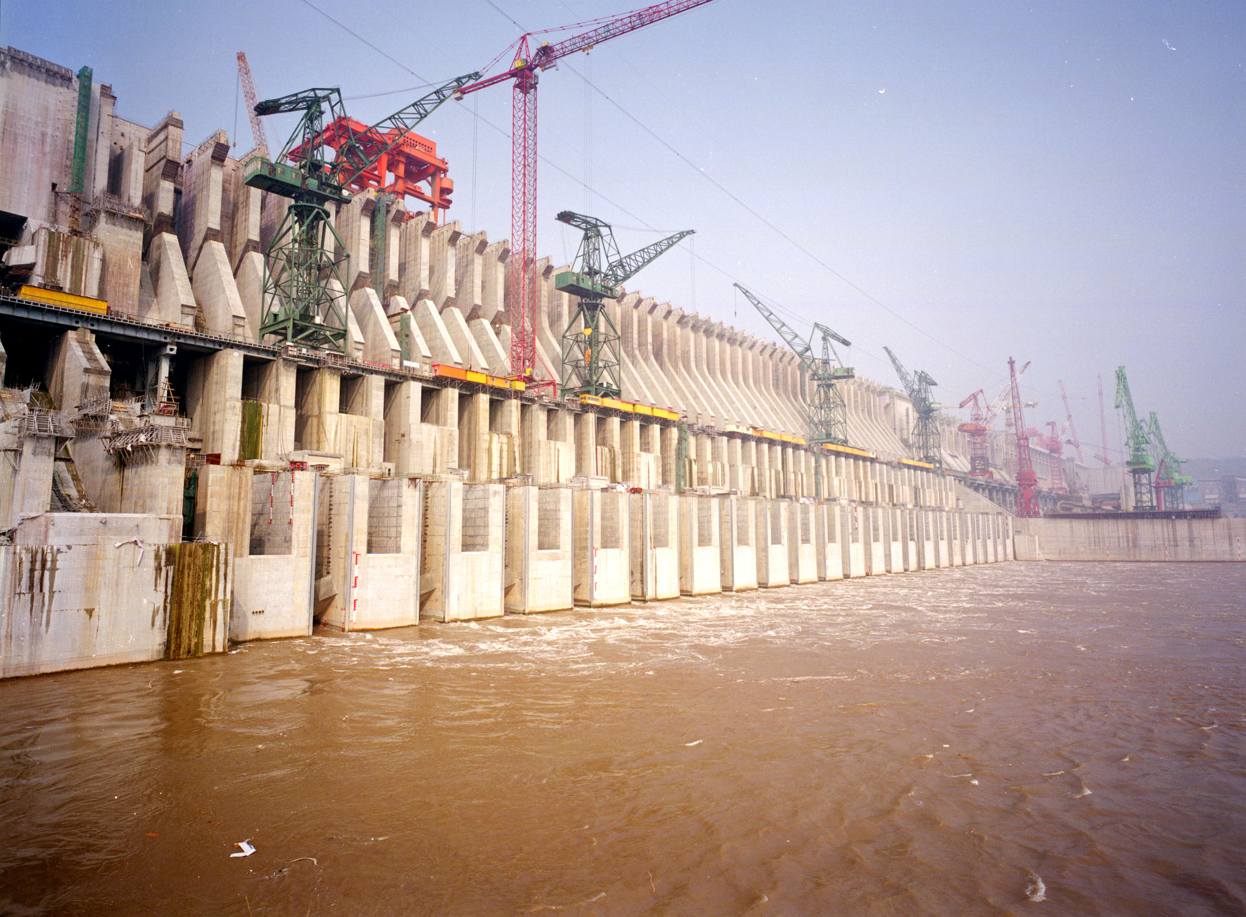
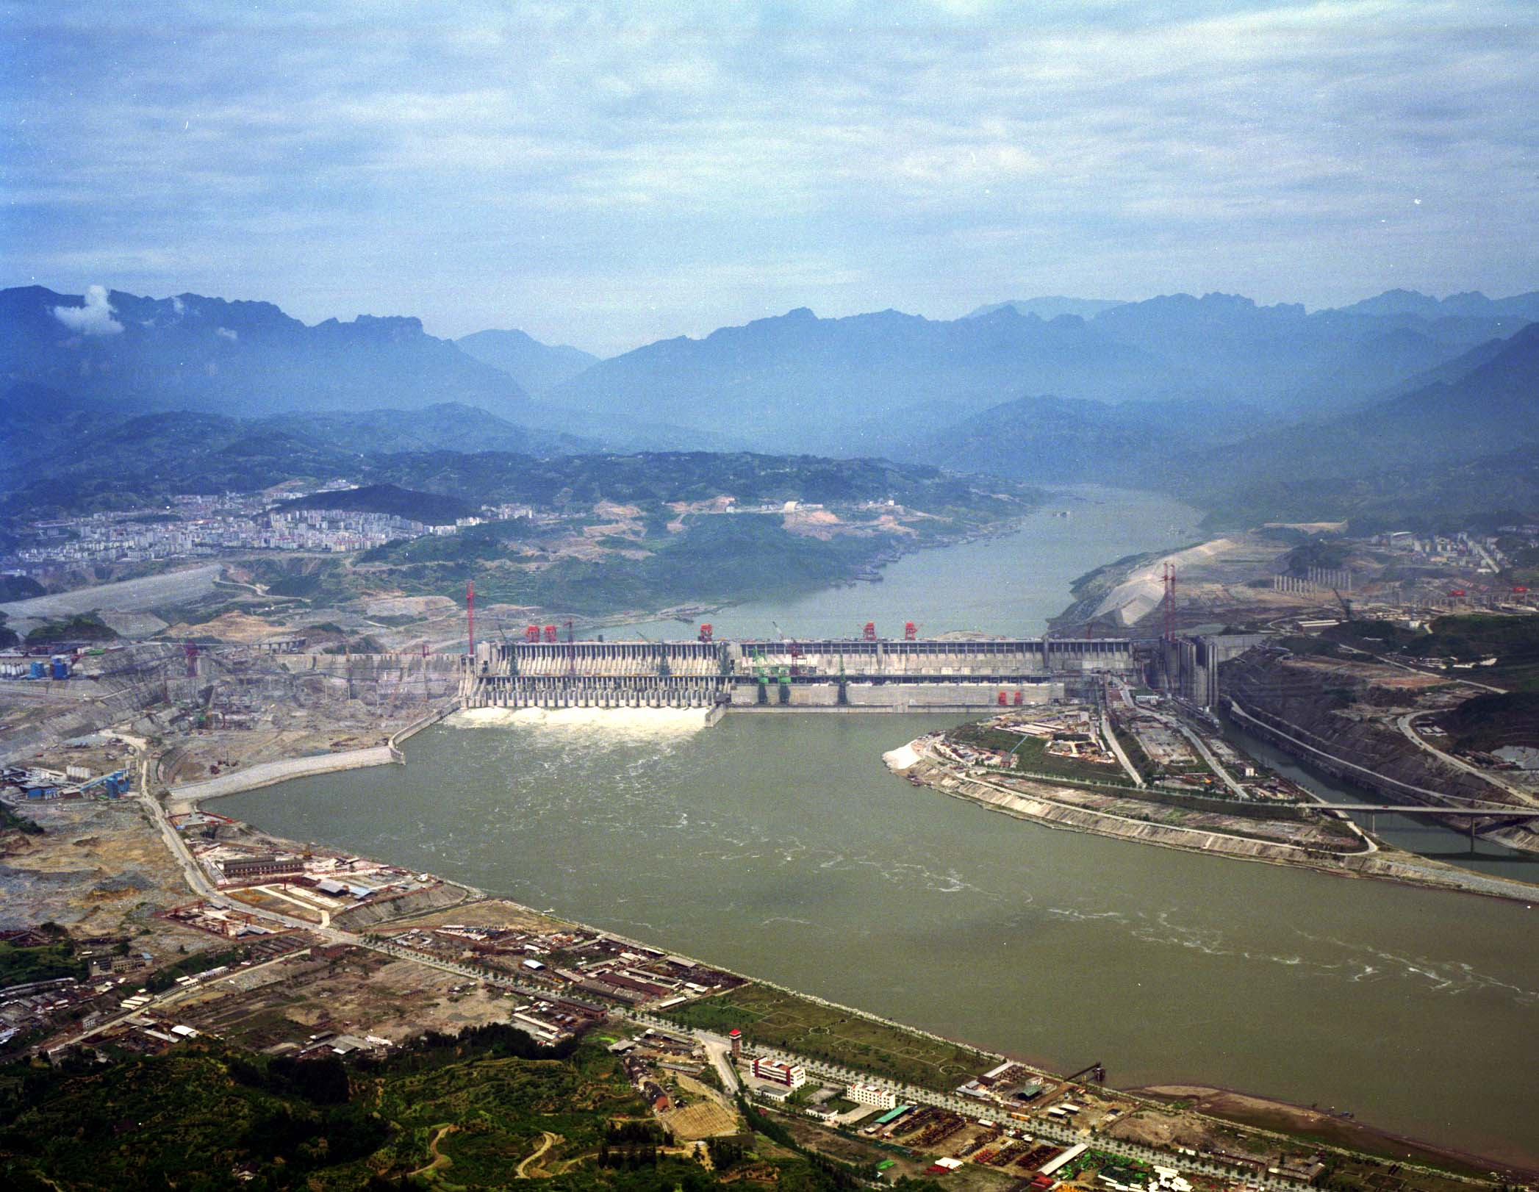
comprehensive benefits mainly in flood control, power generation and navigation improvement. This multi-purpose project attracts worldwide attention with its largest hydropower station in the world with a capacity of 18,200 MW to be installed. The project construction started in 1993. In 2003, the reservoir will be partly impounded and the first group of units (4×700 MW) will be put into operation. The participants will be invited to visit the magnificent project during the conference.

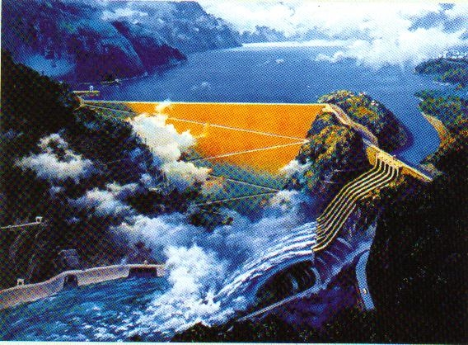
Shuibuya Project is near Yichang. It is the most upper project in Qingjiang River Basin. The dam site to the downstream Geheyan Hydropower Station (The lower part of the dam is arch dam and the upper part is gravity dam , H=151m,completed) is 92km. Shuibuya concrete facing rockfill dam with height of 233m, ranking the highest one of CFRD in the world at present. The Station adopts the diversion-type underground powerhouse. It is designed to install 4 generating units of 400MW each. In January 2000, the State approved the project proposal. The construction of the main works of the station commenced in 2002. The first generation unit will be put into operation in 2006 and all four generation units will be completed in 2008.

Themes
- Design, construction and monitoring of high Concrete Face Rock-filled Dam (CFRD)
- Design, construction and operation of concrete dams
- Mass concrete mix design and optimization , reasonable dosage of additives
- Stability of large hydroturbine sets of power station and operation experiences
- Uprating, rehabilitation and performance improvement for hydroturbine of power station

Language
The working language of the conference is English.

Call for Papers
Papers addressing the conference themes are solicited and encouraged to be presented. The completed paper should be submitted to the Secretariat before February 29, 2004.

Registration
Registration will start on October 1, 2003. The registration forms will be distributed with the Second announcement of the Hydropower’2004, according to the return message or the pre-registration forms, which can be copied from the first announcement of Hydropower’2004. The registration fee is US$400.

Post Conference Study Tours
A1: Three Gorges – Chongqing (3 days, US$450 per person)
A2: Three Gorges – Qingjiang Geheyan Project, Shuibuya Project (2 days, US$300 per person)
A3: Three Gorges –Xi’an City – Beijing (4 days, US$600 per person)

Correspondence Address
All pre-registration forms, abstracts and correspondence concerning the Conference Hydropower’2004 should be sent to Secretariat of LOC, to the following address:
Mr. Gao Fenglong
Secretariat of LOC, Hydropower’2004
IWHR
20 West Chegongzhuang Road, P.O. Box 366, Beijing 100044, P.R. China
Tel: +86-10-68412173 Fax: +86-10-68412316
Email: hanlm@iwhr.com Website：http://www.icold-cigb.org.cn

International Conference
Hydropower’2004
May 24-26, 2004, Yichang, China

PRE-REGISTRATION FORM

Name Title: Prof.□ Dr.□ Mr.□ Ms□
Last name Given name
Affiliation
Mailing address
_________________City Country________________ Zip code

Telephone Fax
E-mail
For the following, please tick appropriate:
- I am planning to attend the Conference
□ I am planning to attend the post conference study Tour A1 □ A2 □ A3 □
- I am planning to submit a paper, paper title:

- Please keep me informed about the Conference

Signature _________________Date___________________

Please return to:
Mr. Gao Fenglong
Secretariat of LOC
IWHR
20 West Chegongzhuang Road, P.O. Box 366, Beijing 100044, P.R. China
Tel: +86-10-68412173 Fax: +86-10-68412316
Email: hanlm@iwhr.com

