Third Announcement

International Conference
Hydropower’2004

May 24-26, 2004

Yichang, China

Sponsored By:

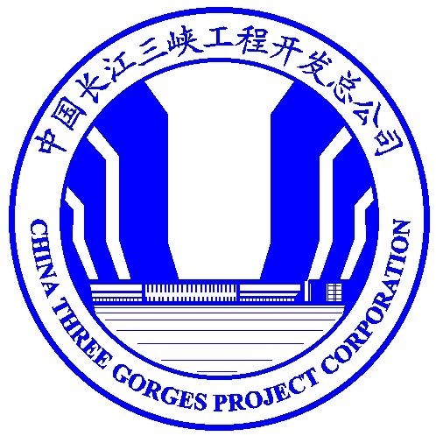
China Yangtze Three Gorges Project
Development Corporation (CTGPC)

Hubei Qingjiang Hydroelectric Development

Co. Ltd (QDC)

Chinese Society for Hydroelectric
Engineering (CSHEE)

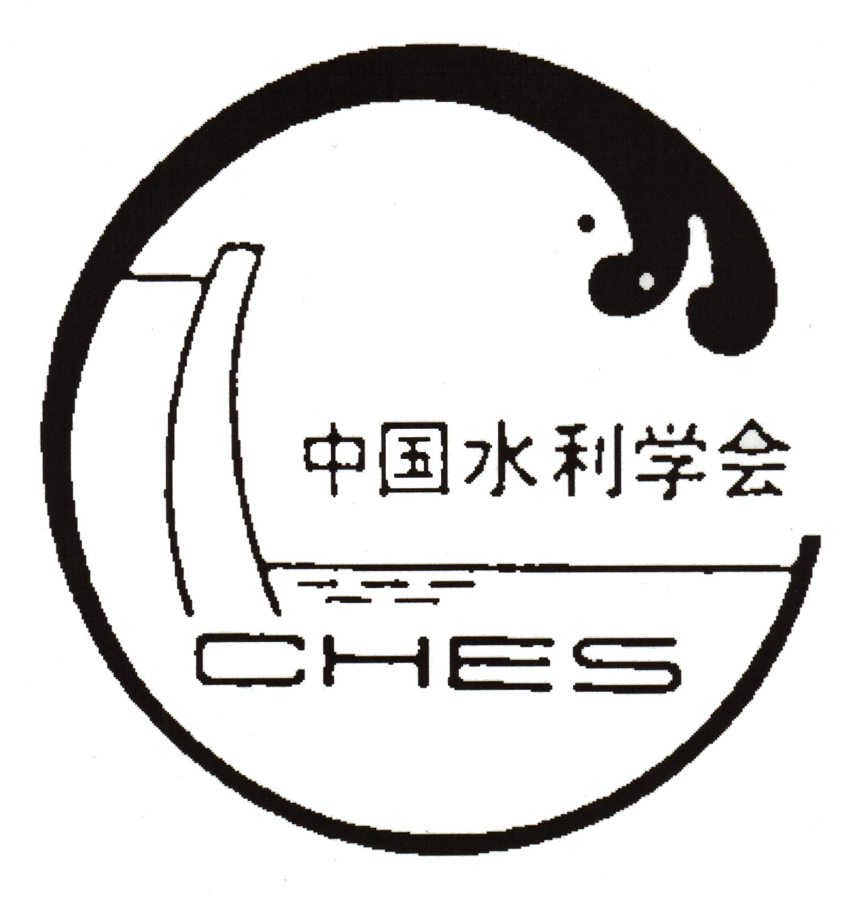
Chinese Hydraulic Engineering
Society (CHES)

Cosponsored By:
National Natural Science Foundation of China (NNSFC)
Chinese National Committee on Large Dams(CHINCOLD)
China Institute of Water Resources and Hydropower Research (IWHR)
INVITATION
The Organizing Committee takes a great pleasure and honor to invite engineers, scholars, specialists, consultants, managers, manufacturers, financiers, officers and all persons who are interested in hydropower development to attend the International Conference Hydropower ’2004, which will be held on May 24—26, 2004 in Yichang City, Hubei Province, China, as post- activities of ICOLD 72nd Annual Meeting that will be held in Seoul from May 16 to 22, 2004. After a successful and fruitful meeting of Hydropower ’96 (1996) and Hydropower’98 (1998), this conference will concentrate on hydropower facilities and structures, especially design, construction, monitoring and operation of high CFRD and concrete dams and the stability of large hydroturbine sets of power station and relevant operation experiences.
The objective of the International Conference Hydropower ’2004 is to provide a forum for discussion on key issues and exchange of information among researchers, scholars, engineers and decision-makers in all aspects of hydropower engineering. At the conference the attendants are encouraged to present their latest research results and exchange their experiences in hydropower development.
The International Conference Hydropower’2004 is sponsored by China Yangtze Three Gorges Project Development Corporation, Hubei Qingjiang Hydroelectric Development Co. Ltd., Chinese Society for Hydroelectric Engineering and Chinese Hydraulic Engineering Society, and co-sponsored by National Natural Science Foundation of China, Chinese National Committee on Large Dams and China Institute of Water Resources and Hydropower Research.

ORGANAZATION
Scientific Committee  Chairmen：  Pan Jiazheng Vice-President  (Chinese Academy of Engineering)  C. B. Viotti (Brazil) President, (ICOLD)  Vice Chairmen：  Gao Jizhang President, IWHR  Cao Guangjing CTGPC  Secretaries General：  Tang Shu IWHR  Lu Yihui IWHR | Local Organizing Committee  Chairman：  Lu Youmei CTGPC  Vice Chairmen：  Zhu Erming CHES  Zhou Dabing  Lin Chuxue CTGPC  Wang Jinyuan QDC  Secretaries General：  Chen Hongbin CTGPC  Chen Runfa QDC  Gao Fenglong IWHR
GENERAL PROGRAM
Date | Time | Activity
May 23 (Sunday) | Full day | Registration
May 24 (Monday) | Full day | Technical visit on TGP
May 24 (Monday) | Evening | Welcome Reception
May 25(Wednesday) | Morning | Opening Ceremony  Invited Lectures
May 25(Wednesday) | Afternoon | Technical sessions
May 25(Wednesday) | Evening | Free
May 26 (Tuesday) | Morning | Technical sessions
May 26 (Tuesday) | Afternoon | Technical sessions  Closing Ceremony
May 26 (Tuesday) | Evening | Farewell Banquet
LOCATION
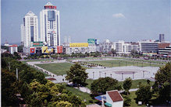
The Conference will take place on the construction site of Three Gorges Project, which is located near Yichang city, Hubei Province. The city has been proved by archeologist that there existed human traces at least 100,000 years ago, and has long been the capitals of different states or prefectures for over 2,000 years. Yichang is a tourist city with a variety of attractions rich in historical sites and cultural relics. Recently as rapid economic development Yichang has also become a modern city with convenient transportation and communication facilities. The flight between Beijing and Yicahang is available every day.
THEMES
- Design, construction and monitoring of high Concrete Face Rock-filled Dam (CFRD)
- Design, construction and operation of concrete dams
- Mass concrete mix design and optimization, reasonable dosage of additives
- Stability of large hydroturbine sets of power station and operation experiences
- Uprating, rehabilitation and performance improvement for hydroturbine of power station
LANGUAGE
The working language of the conference is English.

PAPER SUBMISSION
Papers addressing the conference themes are solicited and encouraged to be presented. Two copies of the completed paper in English and its saved floppy disk (WORD DOC. file) should be submitted to the Secretariat of Local Organizing Committee of the Conference (LOC) before February 29, 2004 by regular mail, and the paper is also need to be submitted by email at the same time. The paper must include the affiliation, mailing address of the first author, fax number and e-mail address if possible.
All papers accepted before the time limit will be included in the proceedings of the Hydropower’2004. The paper should be typed according to the INSTRUCTION FOR PAPERS. Authors should guarantee the quality of their papers both in terms of content and language, in order to avoid rejection by the reviewers. Please read the INSTRUCTION FOR PAPERS carefully!
REGISTRATION
The Registration Form (A) is enclosed in this bulletin. Which should be completed and return to secretariat of the conference by March 25, 2004. Please be notified that registration can only be effected upon receiving both the Registration Form (A) and Form (B) with correct payment.

REGISTRATION FEE (in US$)
 | March 25, 2004 | March 25, 2004
Participant | 500 | 550
Young Participant  (35 years old or under) | 250 | 270
Accompanying person | 250 | 270

The payment of registration fee will cover a set of proceedings (for participant only) and all the activities shown in the program.
ACCOMMODATION
Participants will stay in the Three Gorges Project Hotel. The Local Organizing Committee has reserved a number of rooms at preferential rate (room rate includes breakfast and service charge) in two Buildings of the Three Gorges Project Hotel.

Hotel | Star | Category | Single occupancy | Double occupancy
NAYUNLOU | **** | Standard room | USD 56/room | USD 60/room
ZHENCHUNLOU | ** | Standard room | USD 26/room | USD 30/room
To make your hotel reservation, please complete the registration form and return it to the Secretariat by April 20, 2004. There is no guarantee that reservations can be made after this date. The hotel booking will be made on the basis of first come, first served. If you want to share a double occupancy room, please indicate your roommate’s name on the Registration Form (A).
PAYMENT
The attached Payment Form (B) should be also completed and retuned with Registration Form (A). Registration fee, hotel fee and tour fee should be in US dollars and made payable by the one of following methods.

Payment in Advance
- Bank transfer
Account №: 00038018241014,
Account Name: CICCST/Hydropower’2004
Bank Name: Bank of China Head Office, 1 Fuxingmennei Ave., Beijing 100818, China.
Bank charges are the responsibility of the payee and should be paid at source. To avoid any misunderstanding and for the protection of the participants’ interests, a duplicate or photocopy of the remittance order from the bank should be sent with the Registration Form B to the Secretariat. The name of the participant as well as details of payment should be clearly marked on the remittance order.

- Bank draft
Payment to: Hydropower’2004/CICCST
Mail to:
Secretary General of Hydropower’2004
Dept. of International Cooperation, IWHR
P.O. Box 366, No. 20 West Chegongzhuang Road, Beijing 100044, China
Fax: 86 10 68412316

- Credit card
Only Master Card, Visa Card, American Express Card, Diners and JCB Card will be acceptable. Please fill the necessary information in the Credit Card payment and sign your name on the Registration Form (B). Fax or mail the Payment Form (B) to the Secretariat of LOC. Additional 4% bank charge will be charged in the case of payment by cards.

Payment on-site
Cash (in US$ or equivalent RMB) and credit card (Visa, Master Card and American Express) will be accepted.
OFFICIAL RECEIPT
All participants will receive a written confirmation from the LOC as soon as their registration form with correct payment have reached the account number mentioned above in form of fax, letter or E-mail. The confirmation letter is to be shown on the registration desk upon his/her arrival. A formal receipt will be given at the registration desk.
CANCELLATIONS
Cancellation must be made in writing to the LOC. The refund will be two months after the Conference.

 | By April 30. 2004 | After April 30 2004
Registration Fee | 75% refund | 50% refund
Tour Fee | 90% refund | 70% refund
STUDY TOUR

Post Conference Study Tours

Tour A1: (From TGP to Chongqing City, 3days, US$450 per person)

27 May (Thursday)
Tour will begin after supper, overnight in the boat

Friday. May 28

By boat full day, the detailed agenda will be made on the Luxury passenger liner Lodging will be on Boat at night, Breakfast, Lunch, Dinner on Boat

Saturday, May 29
By boat full day, Breakfast, Lunch, Dinner on Boat

Sunday, May 30
Arrival in Chongqing City, the fourth Municipal City of China, and end of this tour.

Tour A2: (From TGP to dam site of Shuibuya CFRD, 233m high, 2 days, US$300 per person)

Friday. May 28
Morning: The participants will depart for Geheyan Project by coach, Lunch in Geheyan.
Afternoon: visit Geheyan Project and depart for Shuibuya CFRD by boat. Lodging at Shuibuya dam site.

Saturday, May 29
Morning: Technical visit on Shuibuya CFRD and discussion, Lunch at the dam site.
Afternoon: Return to Yichang City by coach and end of this tour.

Tour A3: (From Yichang City to Xi’an City then to Beijing, US$600)
Saturday, May 28
Afternoon: Yichang to Xi’an by air, lodging in 4* Hotel
Evening: Visit City Wall
Sunday, May 29
Full day: Visit Terra Cotta Warrior, Huaqing Pond, and Banpo Village Museum
Evening: Performance of Songs and Dances of Tang Dynasty
Monday, May 30
Morning: Visit Shaanxi History Museum
Afternoon: Fly from Xi’an City to Beijing
Tuesday, May 31
Full day: Visit Great Wall
The tour is ended in Beijing.
CORRESPONDENCE
All registration forms, final papers and correspondence concerning the Conference Hydropower’2004 should be sent to Secretariat of LOC, to the following address:
Mr. Gao Fenglong
Secretariat of LOC, Hydropower’2004
Dept. of International Cooperation, IWHR
20 West Chegongzhuang Road, Beijing 100044, P.R. China
Tel: +86-10-68412173 Fax: +86-10-68412316
Email: hanlm@iwhr.com
Website：http://www.icold-cigb.org.cn
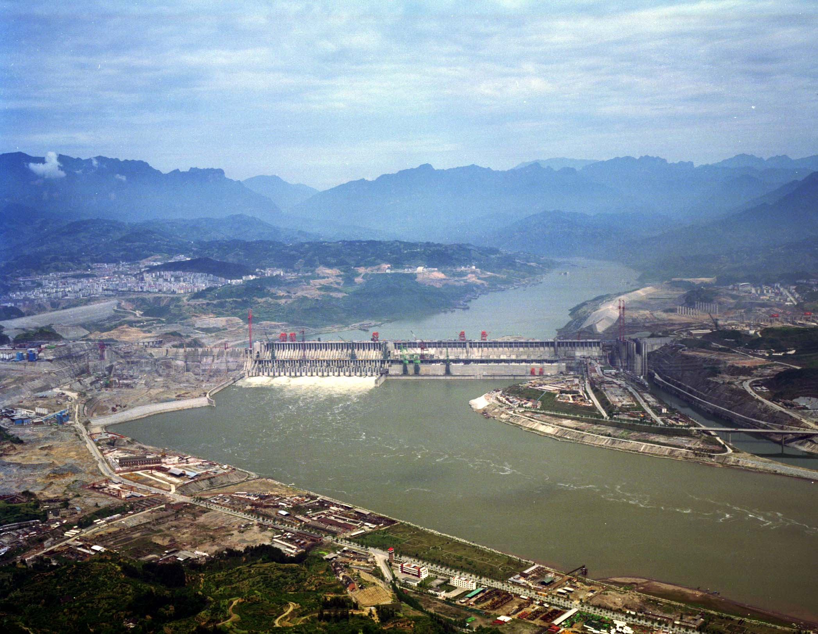
THREE GORGES PROJECT
The Three Gorges Project (TGP) is located 40 km above the Yichang City. It is a vitally important and backbone project in the development and harnessing of the Yangtze River. TGP serves as a multi-purpose hydro-development project producing comprehensive benefits mainly in flood control, power generation and navigation improvement. This multi-purpose project attracts worldwide attention with its largest hydropower station in the world with a capacity of 18,200 MW to be installed. The project construction started in 1993. In 2003, the reservoir will be partly impounded and the first group of units (4×700 MW) will be put into operation. The participants will be invited to visit the magnificent project during the conference.
SHUIBUYA PROJECT
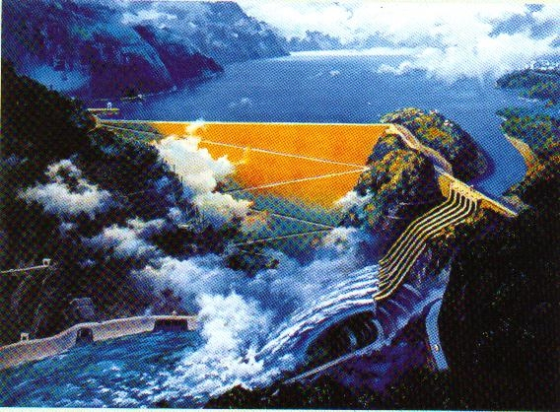
Shuibuya Project is near Yichang. It is the most upper project in Qingjiang River Basin. The dam site to the downstream Geheyan Hydropower Station (The lower part of the dam is arch dam and the upper part is gravity dam , H=151m,completed) is 92km. Shuibuya concrete facing rockfill dam with height of 233m, ranking the highest one of CFRD in the world at present. The Station adopts the diversion-type underground powerhouse. It is designed to install 4 generating units of 400MW each. In January 2000, the State approved the project proposal. The construction of the main works of the station commenced in 2002. The first generation unit will be put into operation in 2006 and all four generation units will be completed in 2008.
THREE GORGES PROJECT HOTEL
The Hotel is located in the Three Gorges Project Site, 40 km from the city center of Yichang and 60 km from the Yichang airport. The International Convention Center of the Hotel could provide conference rooms with different size and facilities to meet the needs of variable meetings. In addition, the surrounding environment of the hotel is pleasant and elegant. Accommodation, meals and recreation will be very easy and comfortable with the restaurants, bars and business centers of the Hotel.
TRANSPORTATION

Travel to Yichang

Yichang City is about 300 km from Wuhan. Yichang City connects many important cities of China by flights. Every day, there is 1 flight from Yichang to Beijing, 3 flights to Shanghai, 2 flights to Guangzhou and one flight to Kunming. The participants would be suggested to include the air ticket from their entrance city of China to Yichang in their whole travel package.

Travel to Three Gorges Project Hoteal

The Three Gorges Project Hotel is 60 km from Yichang Airport. Because of the construction of Three Gorges Project, all vehicles which come to and out from the Three Gorges Project site must have a special permit. Taxis are not permitted to come to the Hotel. For guarantee a convenient transportation between Yichang airport and the Hotel, a special group will be arranged at Yichang Airport to meet participants, providing them with free transportation to the hotel.
WEATHER
The weather in Yichang is pleasant in May, with an average temperature of around 20 °C -25°C during the day.

