 | 
  Wholly constructed the first dam on the Yangtze river-Gezhouba Project
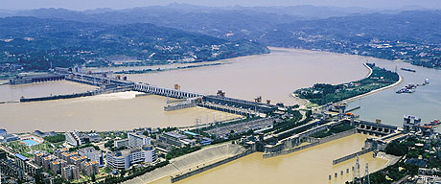
Gezhouba Hydroelectric Project, the largest HPP in 1980’s in China and also the first HPP on Yangtze River, third largest river in the world and largest river in China, was constructed by CGGC wholly. CGGC was named after this Project.
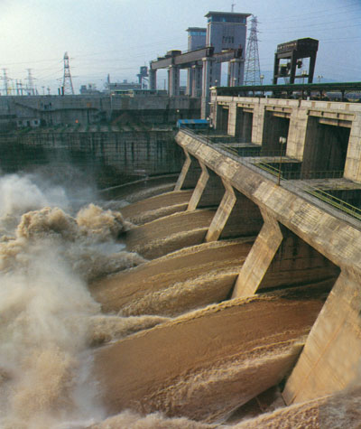
Gezhouba HPP consists of three shiplocks, spillway of 27 openings, sluices of 15 openings and powerhouse and is of typical gated dam. During the construction period, totally earth-rock work of 108.04million m3, concrete placement of 114.58million m3, metal structure manufacturing and installation of 223,000t, rebar manufacturing and installation of 76,000t, installed turbo-generator units of 21 sets, installed capacity of 2,715MW were achieved and over 100 national records were established in China at that time. River closure of the main channel of the Yangtze River for the construction of Gezhouba Project was awarded the “National Gold Medal of High Quality Project” and the works completed on the second and third channels as welll as the installation of the turbo-generator units were granted the “Special-Class Prize of National Science & Technology Advancement”. The successful practice in the Gezhouba Project by CGGC functioned as the actual preparation for the construction of Three Gorges Hydroelectric Project, indicating that Chinese hydroelectric construction technology ranked in the leading position in the world.
