As the start of cascade development of Qingjiang river in Tujiazu county, Changyang, Hubei, Geheyan HPP functions power generation mainly and flood protection, navigation and so on. It consists of dam, powerhouse and ship lift. The dam is concrete gravity dam with maxi height of 151m, crest length of 653.5m and elevation at EL. 206m. The powerhouse is of power intake with 4*300MW turbo-generator units and design annual power production of 3.04billion kwh. The navigation structure is of double-step vertical ship lift accessible for 300t ship with maxi lifting height of 122m and annual single-way passing capacity of 1.7 million tons.
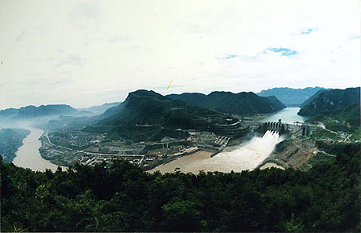
It played significant role in the flood protection in 1998 on Yangtze River. The sixth flood peak rose the water level in Shashi up to 45.30m, highest one in history and the Geheyan dam retained the flood to the most extent and reduced the water level in Jingjiang by 20 ~30cm, thus avoided submerging of Jiangjing for the sake of protecting other cities on the downstream and saved potential loss of billions RMB.
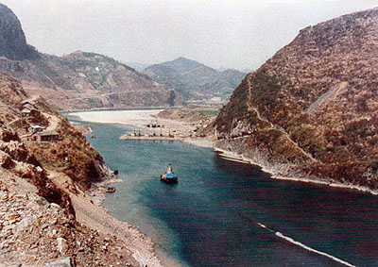
The Original Dam Site

